Memo:
To: Nicolas Dei Castelli, ADB
Wagner Colombini Martins, Team Lead, Logit
Livia Delgado, Logit
Nikolos Archavadze, STS
Zurab Beradze, STS
Re: Parking Survey Report and Data, and Parking Policy
Date: August 12, 2026
On July 3, 2026 a Parking Survey Report (Output 8) and a Parking Policy Report (Output 10) was shared with the ADB. On July 24, 2026 a PPT with updated parking material was shared in a meeting with the client. The data behind these reports was also shared with the ADB in early August. This memo contains proposed ADB comments, subject to Nicolas Dei Castelli confirmation. We have yet to receive formal comments from the PIU so their views are only what was reflected during the July 24, 2026 meeting.
- Comments on the Parking Survey Report
Nicolas expressed a few concerns about the follow issues during the July 24th meeting with the client:
- Show the parking removed as a share of total parking spaces in the impact area, rather than just on the corridor.
On slide 6 of the July 24 PPT, it shows that 80% of on-street parking is removed. Rather than presenting the total share of parking spaces removed from the planned BRT corridor, the report and presentations should present the total share of parking spaces removed from the impact area which includes the surrounding streets and off-street parking. Also, show these figures both in aggregate and at the area level.
For example, according to the data in your spreadsheets on Kentron (which I looked at more closely) an original supply of 534 parking spaces was available ,and after only 224 parking spaces remain. That would yield 58% of the parking spaces in the impact area removed. It looks a little less alarming.

- The presentation of values over 100% for a parking occupancy survey is confusing.
Intuitively, the occupancy rate is supposed to indicate how many parking spaces are likely to be available in a given zone during a certain hour. As such, 100% makes no sense. I looked at the old Georgia on-street parking reports and they also reported occupancy levels of over 100%. I didn’t catch this at the time (not sure if it was my responsibility to do so). I was able to get a result of a maximum of 100% by giving each discrete license plate a 0.5 hour parking time for the hour when the vehicle is first observed and the hour when the vehicle is last observed, assuming that on average the vehicle will be parked ½ hour during its first and last hour.
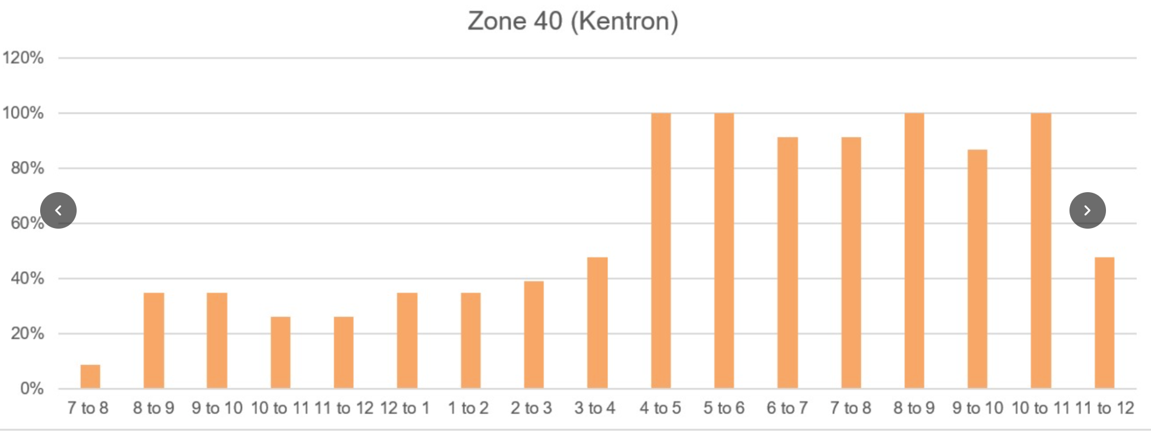
Figure 2. Occupancy rates in Zone 40 recalculated to have a maximum occupancy rate of 100%
I don’t know how much additional data analysis this would require and leave it up to Nico whether or not he wants the occupancy rates recalculated to represent a maximum of 100%. I did it manually which was a lot of work but there is probably a much faster way to do this using some light programming.
- Present the occupancy data on an area by area basis rather than in aggregate.
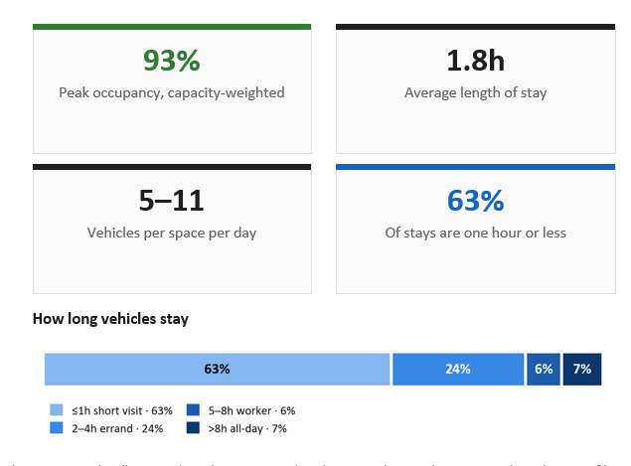
The parking occupancy data in aggregate is far less informative from a policy perspective than the data at the area and zone level. The data was collected in different areas representing three likely different situations from which the whole could be extrapolated, but this second step was never completed. Presenting occupancy survey results at the area level should be relatively straight forward, and I see you are already generating maps for this. The data for the six areas was already aggregated at the area level, so an area level analysis should be easy.
- Issues with the parking spaces removed calculation.
The figures representing parking removed by the project are not based on the latest conceptual design. The PIU is also potentially adding additional parking in some areas and the latest information about this needs to be collected.
From a more detailed look at the data in the occupancy survey spreadsheets, it looks like the calculation of the number of parking spaces remaining after the project was done at too aggregated a level:
Perhaps more accurate calculations exist somewhere else, but this worksheet shows that there is no detailed breakdown in zones where some of the parking has been retained. STS should update this table with a more detailed assessment of remaining parking spaces.
- Other issues
Upon closer inspection of the raw data, a few additional issues emerged.
5.1. Problems with the occupancy data.
In a few of the zone specific worksheets, the time period was missing. As a result when the zone-level data was consolidated into the aggregated data sheet, this data was missing from the appropriate time slot. We corrected it on our own database but you should correct this in your own spreadsheets.
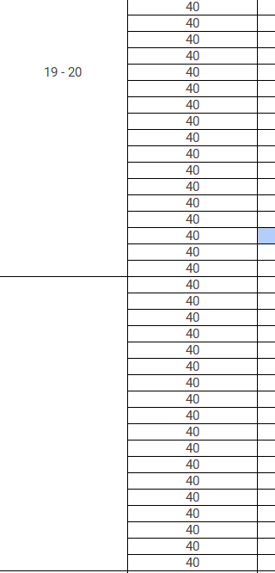
Figure 1. Zone-specific worksheets in a few cases (19, 40) were missing the time period label.
4. Surveyors may have missed some data.
I did a detailed analysis of one zone (40) and found that there were a number of times when the same license plate would be parked in a zone for a long time, say 4 hours, then disappear for an hour, then return to the zone, at an unexpected time, say 8 pm to 9pm. I have highlighted them in yellow below
These instances certainly seem like it was a surveyor error rather than that the car pulled out of the zone for an hour, and then returned. There were about 8 of them for the entire period and they were heavily concentrated in the 8 to 9 period. I suppose its possible that the motorist went to dinner and came back, but seems equally likely that the surveyor missed a few. Perhaps a note should be made that the 8 to 9 window is possibly undercounted?
- Parking Area-level Occupancy Survey results could not be replicated
On slide 4 of the July 24th PPT, the results of the parking occupancy survey data during the peak hour were shown. Kentron is shown to have an occupancy level of 138%.
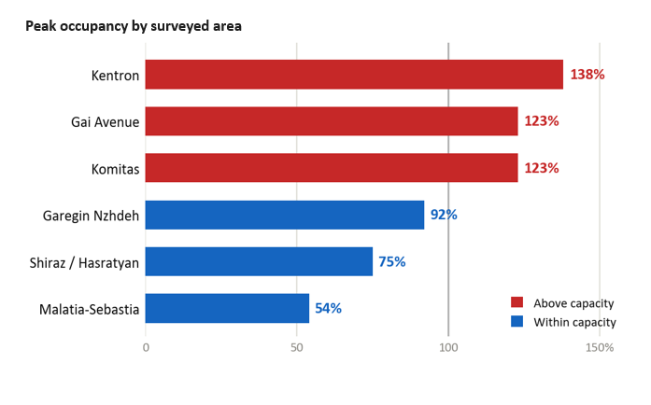
It is not fully clear whether this slide is showing the baseline condition or the ‘with project’ scenario, but it appears to be the baseline condition. I did not have access to the spreadsheets from which the above table was generated. However, when I tried to replicate the results, I found the following:
I processed the database provided and counted the number of vehicles observed per zone for each hour of the survey (7 am to 23 pm). I then compared this to the total parking space available before and after the implementation of the BRT project.
This allowed me to generate the following graph:
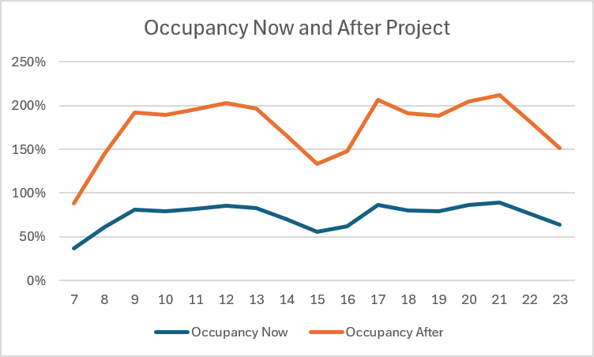
Figure 3. Estimated occupancy rates from the data by hour
Such graphs are useful to isolate the times of day when the occupancy issue is most severe.
The baseline occupancy levels in Kentron, in aggregate, do not seem to be a problem. The highest occupancy rate observed, even without adjusting for the turnover rates, was between 9pm and 10pm, and it was only around 91%. This and the relatively high turnover rate and relatively short duration of stay indicates that the existing parking charging regime downtown is working reasonably well. At no point in the day are all of the spaced downtown are fully occupied. It is not clear how STS got results of 138% occupancy rates in Kentron.
However, when all of the parking spaces are removed, the occupancy rates go way up.

I note that you’ve also been adding some very nice maps of the occupancy rates by Zone. These are really great but I don’t understand what this information is telling us or how these figures were derived:
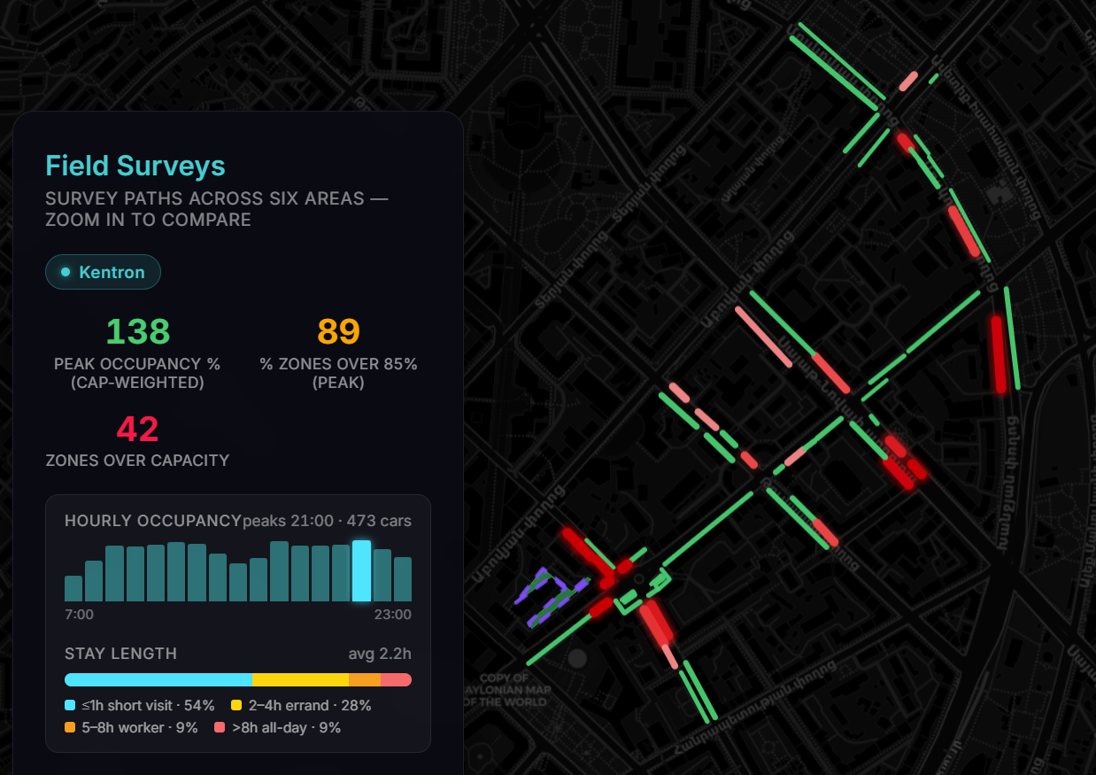
If these spots during their peak occupancy are at 138% occupancy, why are they colored green? What does cap weighted mean? I don’t understand what this graph is telling us and would need to see the underlying data from which it has been derived.

- Comments on the Parking Analysis report

- Too much focus on Opening Residential Yars
Nico was unhappy that the primary solution emphasized in the Parking Analysis presentation was to open residential yards to general parking. This was going to account for by far the largest amount of displaced parking from the corridor. Both the PIU and Nico of the ADB felt that it was unrealistic to expect that the residential yards would take up much of the displaced parking from the corridor. At most this may be a solution in a few specific circumstances.
In Kentron, which we analyzed in detail, only one off-street parking space was identified:
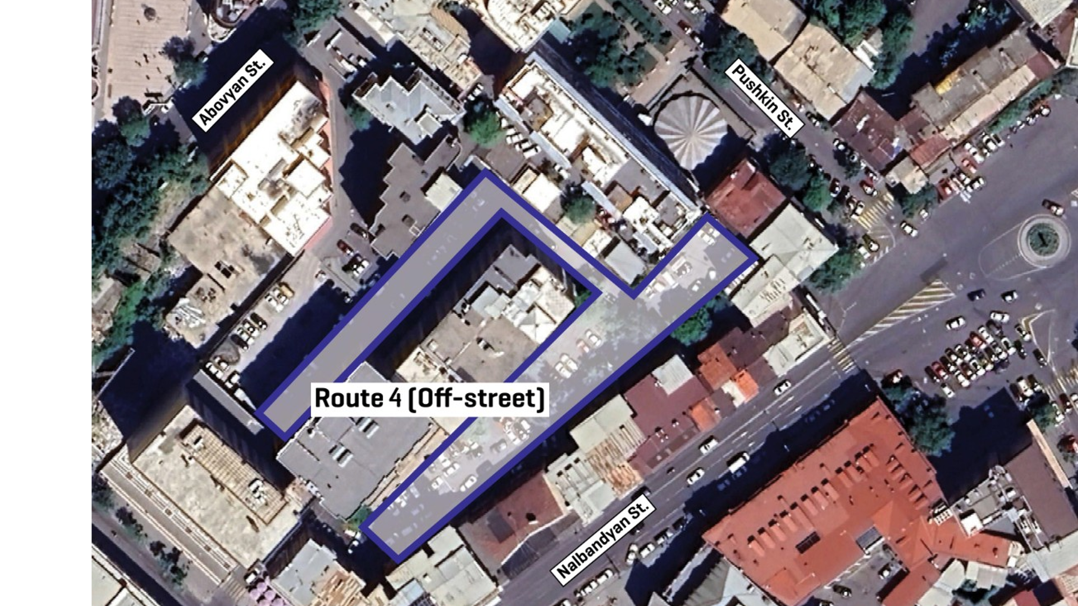
Since there is only one parking yard it would be good to know more about it. Is it open to the general public? Do they already charge? What is the story?
This location had approximately 60 parking spaces, according to the supply survey. This was the sum total of all off-street parking identified within the impact area of the Kentron area. This off-street parking occupancy in Kentron was already at 100% during parts of the day.
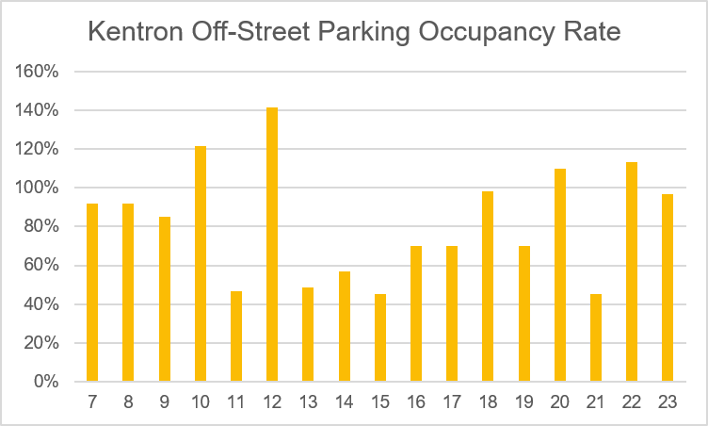
The maximum additional parking spaces available is 30, and even this is dubious for the evening hours, given that the sudden availability of parking spaces occurs at 9 pm but then disappears again at 10 pm, making us doubt the viability of the 9 pm occupancy counts as its would seem an unlikely parking pattern. Its also not clear how there could be such a large negative occupancy, which needs to be explained.

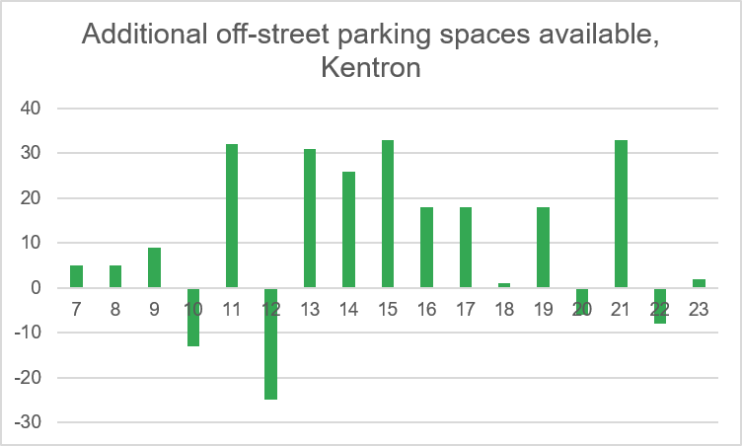
Given that downtown is losing some 310 parking spaces on the corridor, and the most that the one off-street yard could potentially supply is an additional 30 spaces during the afternoon, at least in Kentron opening the off-street yards hardly addresses the problem.
As such, for downtown, more site specific policy recommendations are needed, with some effort at quantification.
- Limited analysis of other measures: Time limits
Having a 2 hour time limit on parking downtown, as is common in many cities around the world, seems like a reasonable suggestion, but the impact it would have should be analyzed. For example, of the 2725 parked vehicles observed in the Kentron area throughout the day, some 766 of them are parked for longer than 2 hours. I couldn’t figure out how to estimate the impact on parking oversupply once the on-street parking is removed, but there is probably a way.
- Limited analysis of other measures: expanding the areas of paid parking
You’ve generated great maps which show the number of parking spaces where parking is currently charged.
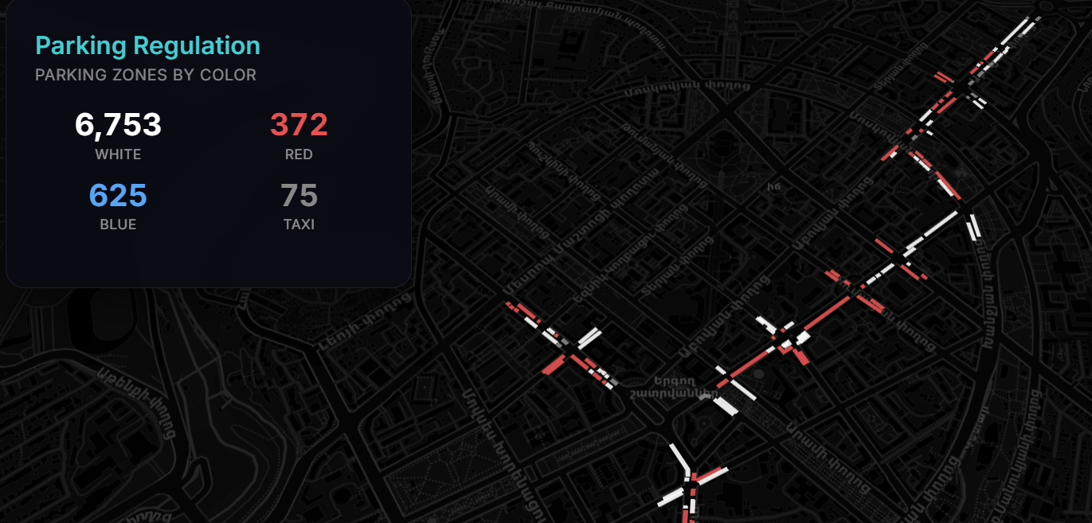
Its seems like it should be possible to quantify the number of parking spaces that could be increased to paid parking, and the impact this might have on occupancy rates.
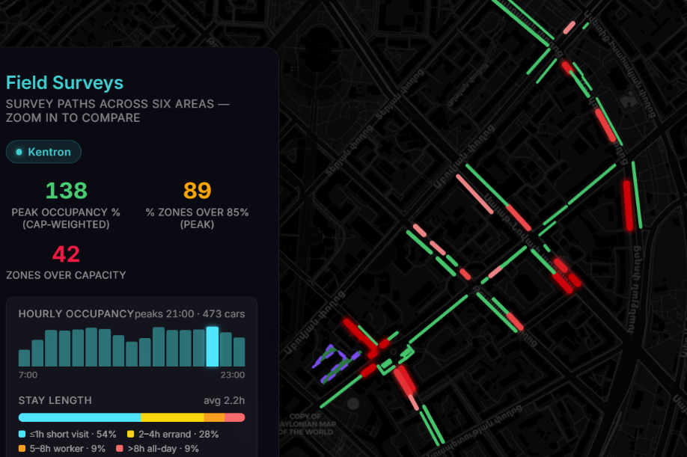
Given recent mapping showing a large amount of variation in the level of parking occupancy within the zones, it seems like simply redistributing where people park within the zone is a viable alternative. This could be encouraged with variable rate pricing, and possibly the introduction of parking apps.
In general the policy measures proposed should be backed up with data and some effort to quantify just how much the proposed measures are likely to address the parking supply issue in each zone would very much strengthen the policy positions being advocated for.

- Other possible policy measures not mentioned at all:
- Increase the parking charges even on the existing charged parking zones, and varying the charges by zone pros and cons (perhaps it requires going through city council: a parking law revision might empower a parking authority to make minor changes within a certain band)
- Giving the revenue to the neighborhood to incentivize participation.
- I am not in favor of expanding the downtown parking supply except as a last resort if required to get our BRT corridor through downtown. Yerevan’s downtown seems incredibly vibrant but most vibrant downtowns in Europe probably have more off-street parking than Yerevan, so finding 300 new parking units would not be the end of the world.

